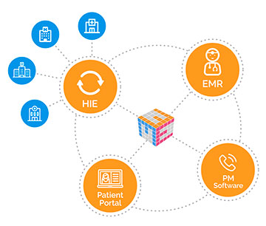For each Dr. visit patient is prompted from the software: “This facility may use your data in the following ways. Do you grant permission for this facility to………” Patient answers yes or no to each question. This software also contains the entirety of that patients health record from birth, providing driect access to their lifetime medical record incresing health literacy, providing for continuity of caree, improving quality of care, and reducing health inequities.

This will be possible due to policy changes at state and federal levels that

1. Create standardized data requirements between states and at the federal level for interoperability between Health Information Exchanges
2. The creation of blockchain technology centers that are designed to securely protect americans health data
3. Mandated individual Health Data Ownership that provides individuals with access to their lifetime health data and complete control over how that data is used.